**Project Info**

**Admin:**

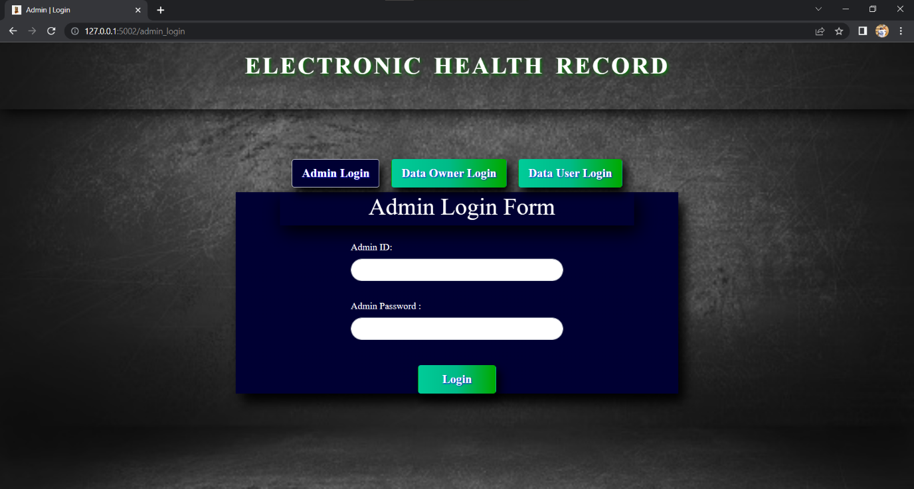

**Fig:**

As we know that, we have 3 persons in our project. Admin, Data Owner and Data user respectively.

Admin can create himself and using those credentials he can able to login in admin login form and then he will be redirected to admin home page .

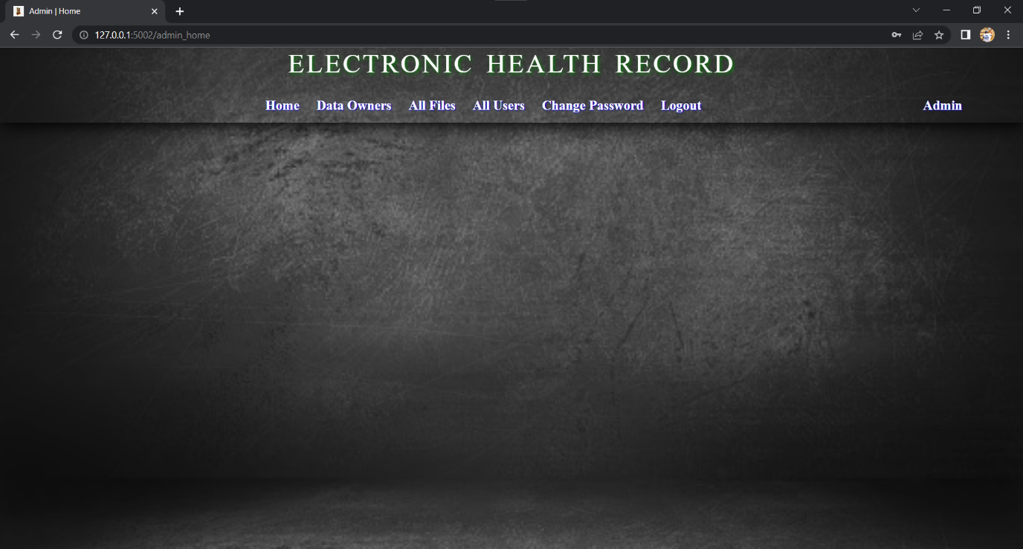

Fig:

In the admin home we have several options like, crate data owner, view the data owners list, edit the data owner, view the data users lists that are created by different data owners and view the files which are uploaded by all data owners.

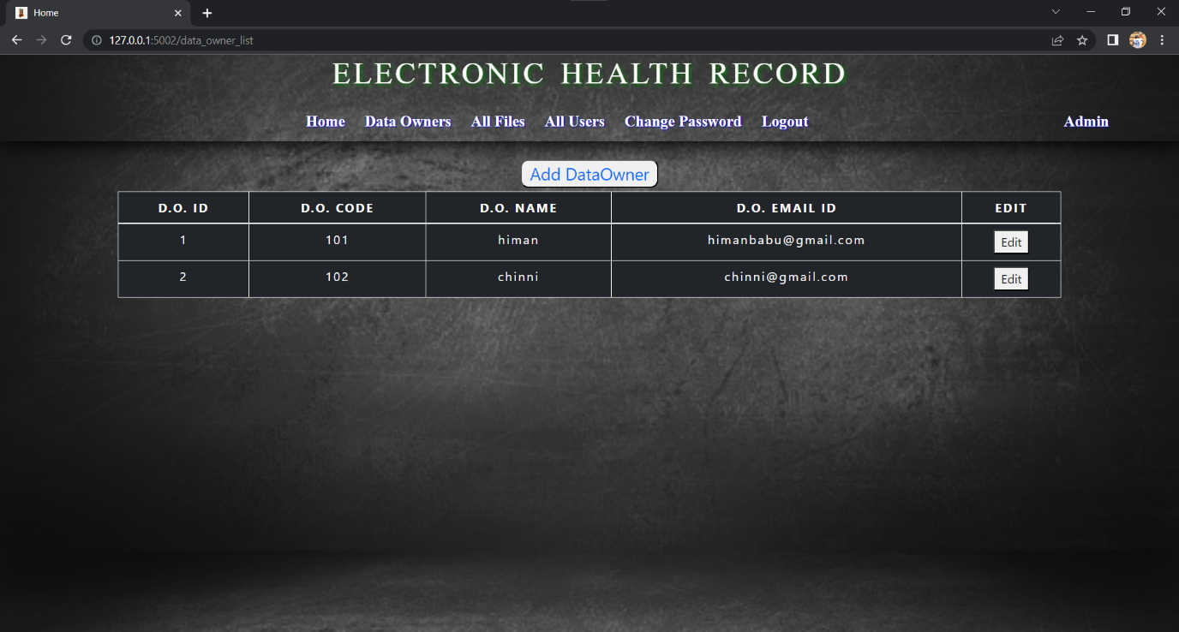

Fig:

The above figure showing the list of data owners who are created by admin. And we have Add Data owner option to add new data owner.

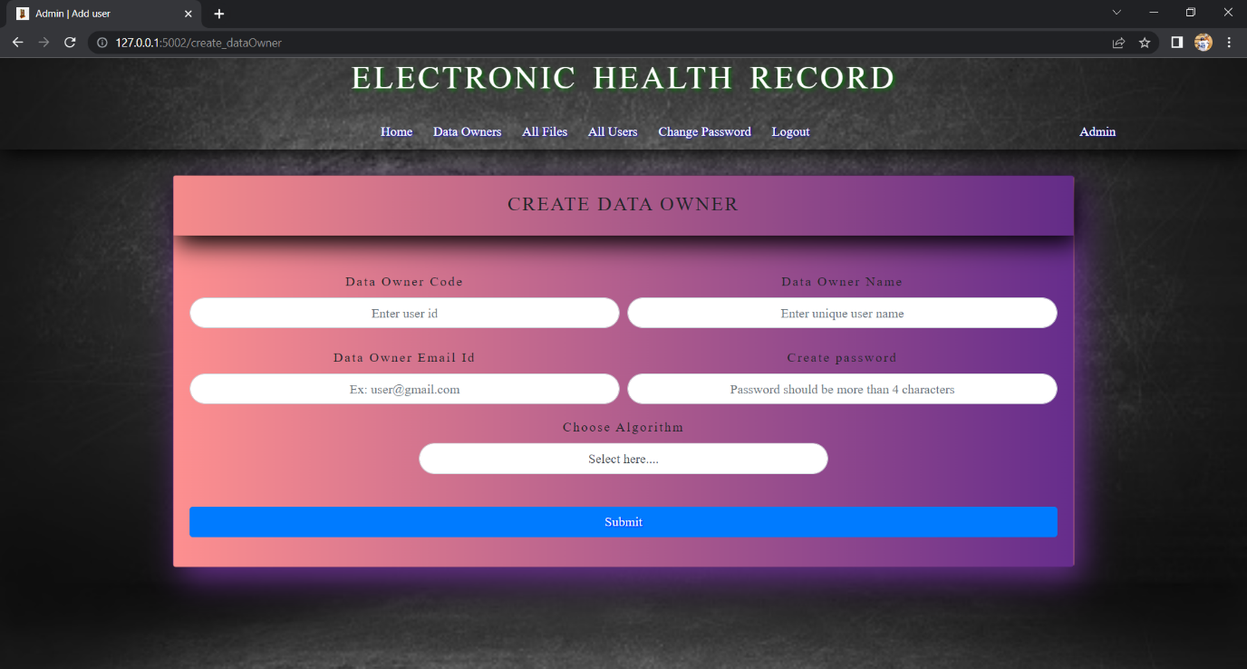

After Clicking on the Add data owner button admin redirected into Create data owner page there he can provide the required details and he can create the data owner.

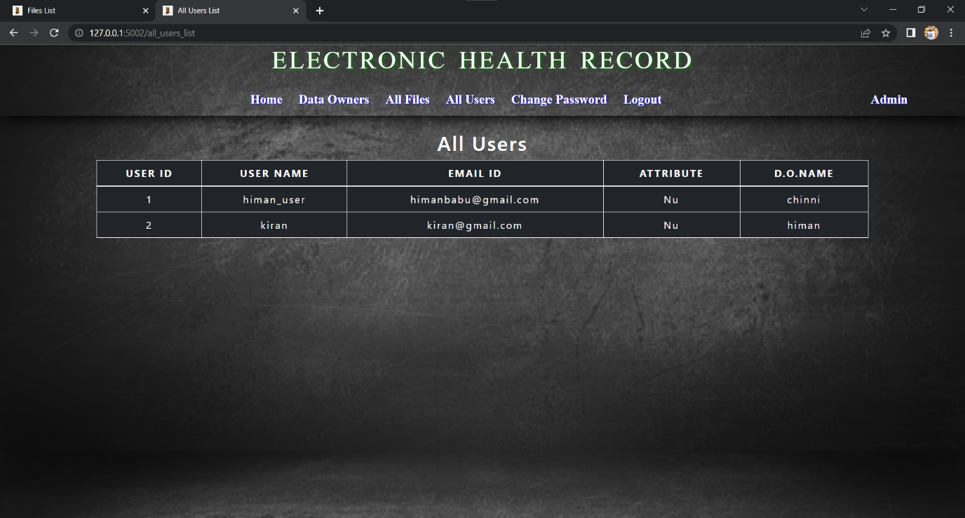

Fig:

The above figure showing the list of data users those are created by all data owners.

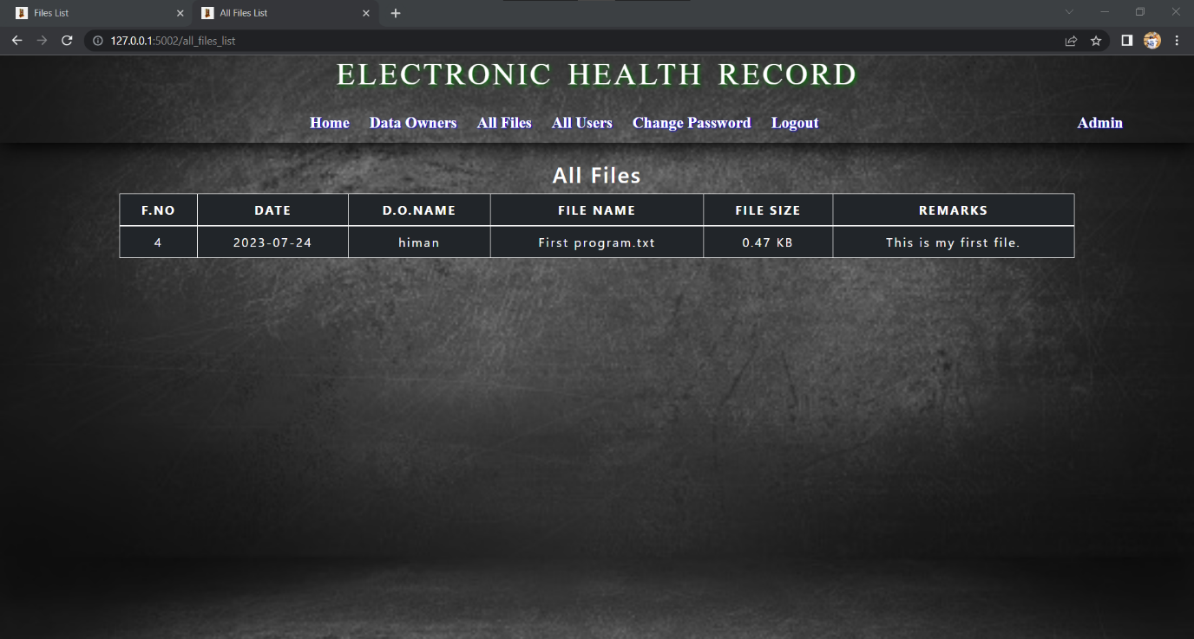

Fig:

Here admin can see the all files which are uploaded by all data owners, and he can see which data owner uploaded that particular file.

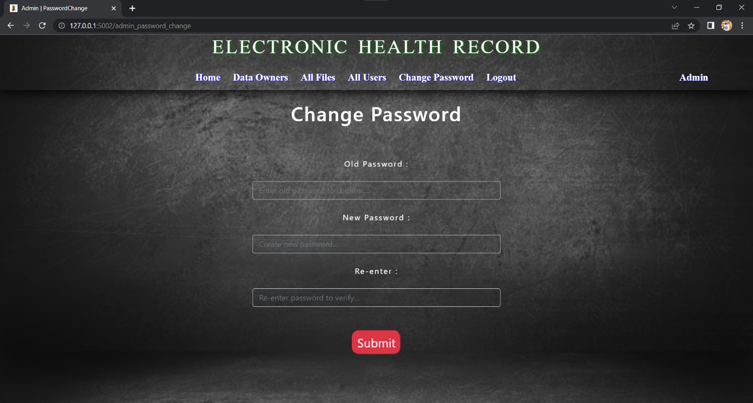

Fig:

For security purpose we given change password option for the admin too. Admin can change his password here by giving his old password and new password.

**Data Owner:**

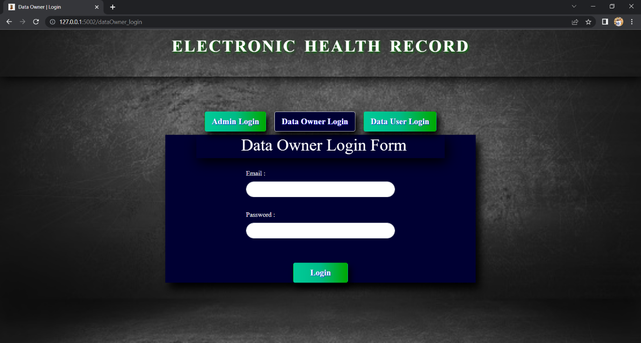

**Fig:**

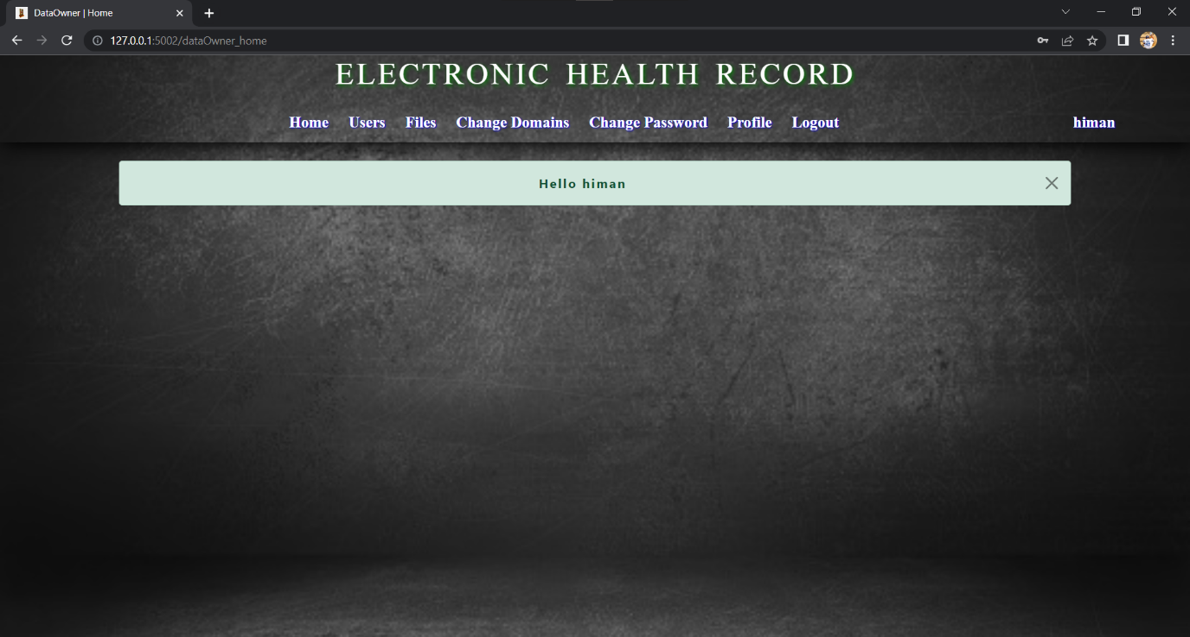

**Fig:**

As shown in the above fig we have login page for data owner, he can login there using the credentials which are given by admin through mail. After successful login he will be redirected to the data owner home page.

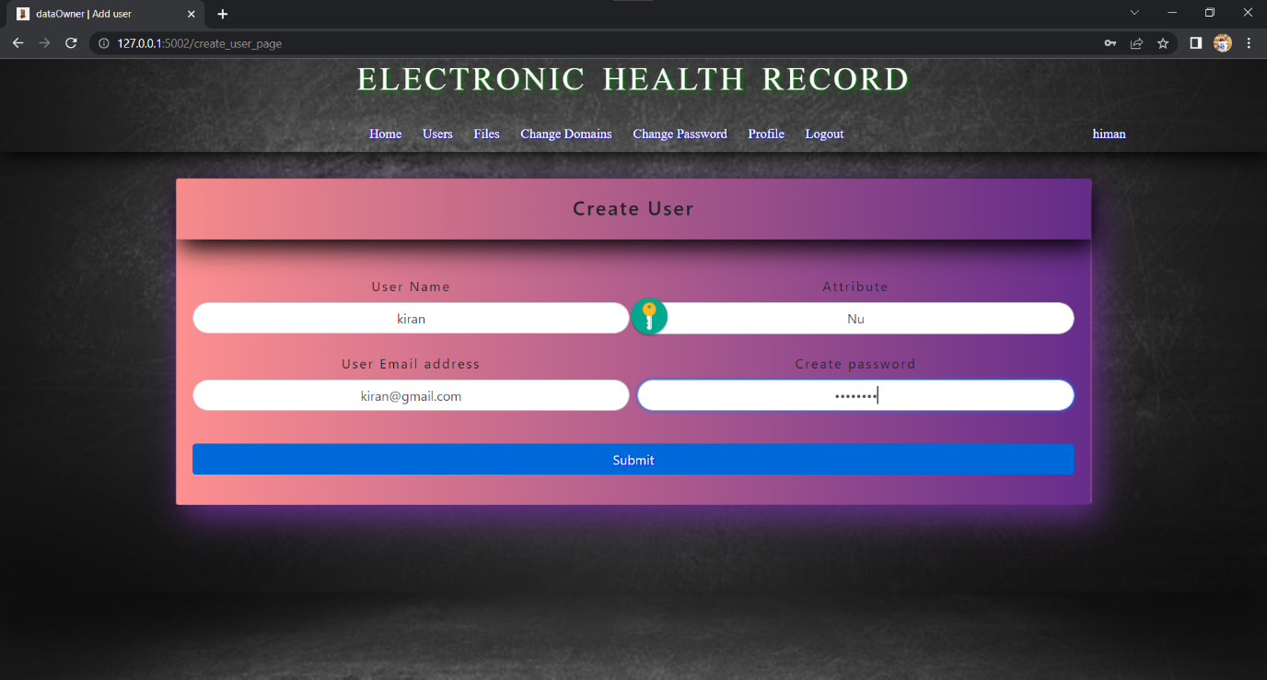

Fig:

Now data owner can create the data user by giving required data and that data user will get the decryption keys from his data owner.

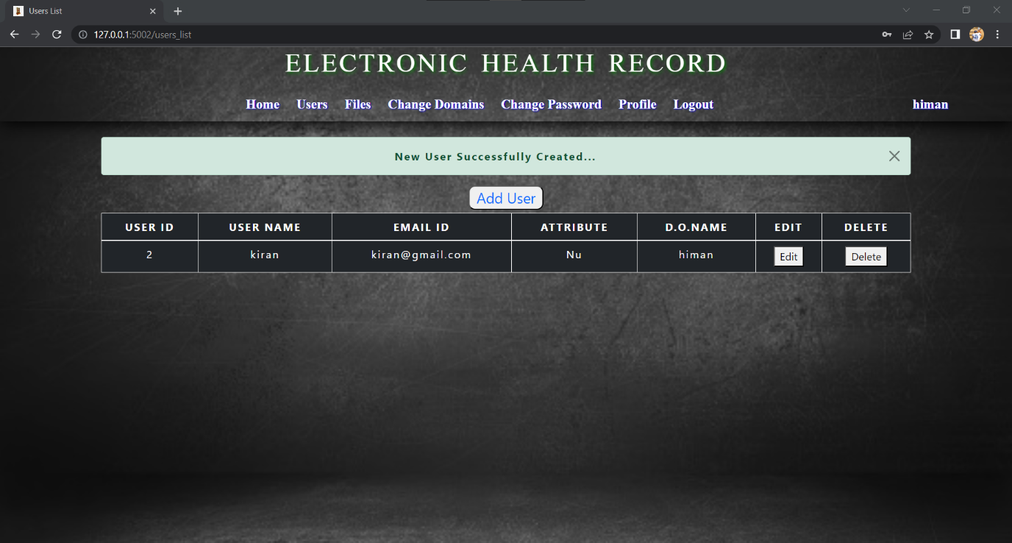

**Fig:**

This is that data users list for this particular data owner, he can edit his details and he can delete if he wants.

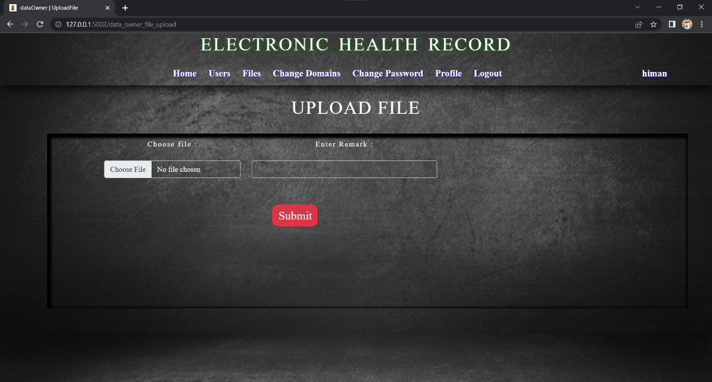

Fig:

Here data owner can upload the files from his local memory and he can write remarks for that file, now we are encrypting that file and saving in cloud named as drivehq.

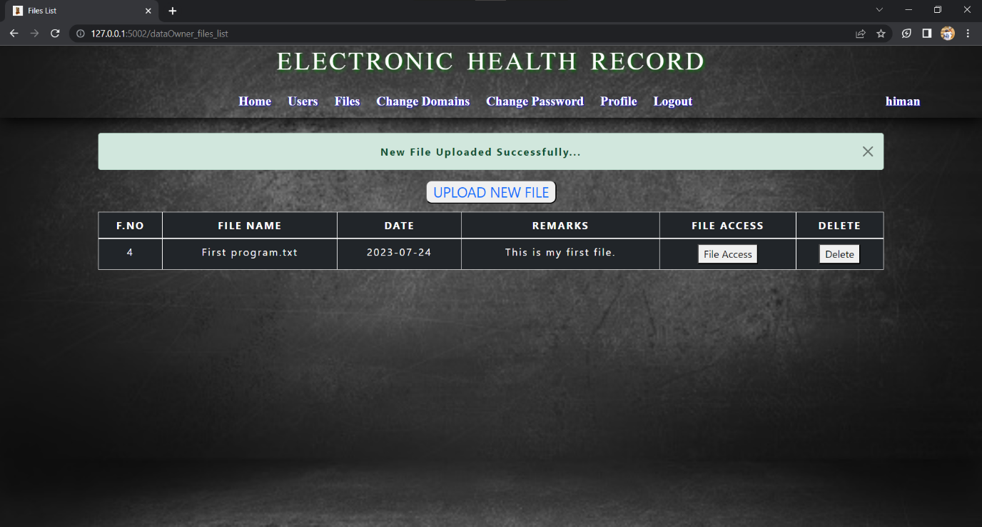

Fig:

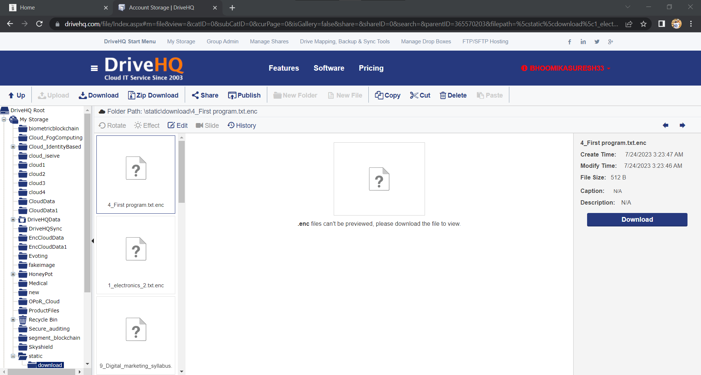

Fig:

This is the drivehq cloud here we can save our encrypted files and later we can retrieve using ftp server.

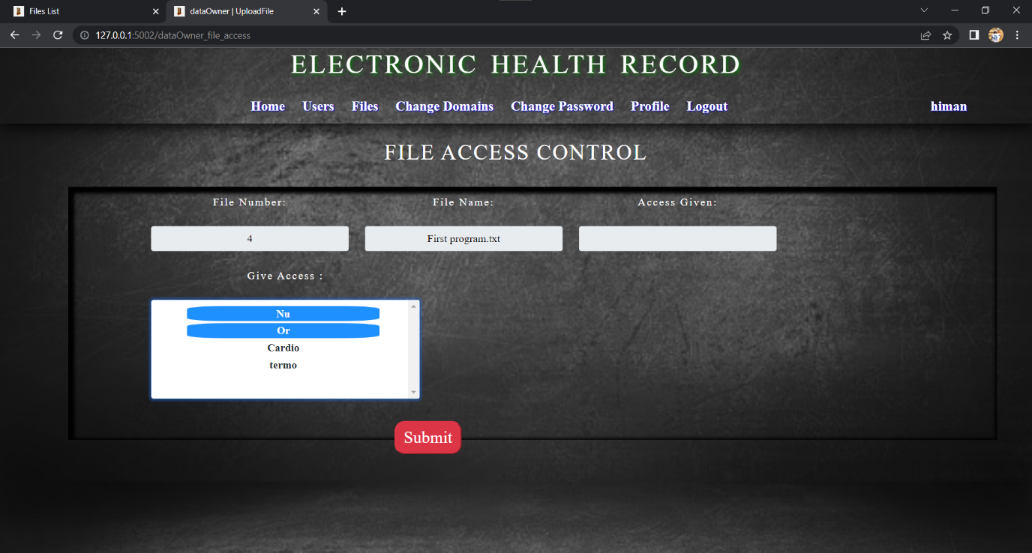

Fig:

This is the file access page, here we can give the access the access and we can modify the access that we already given files.

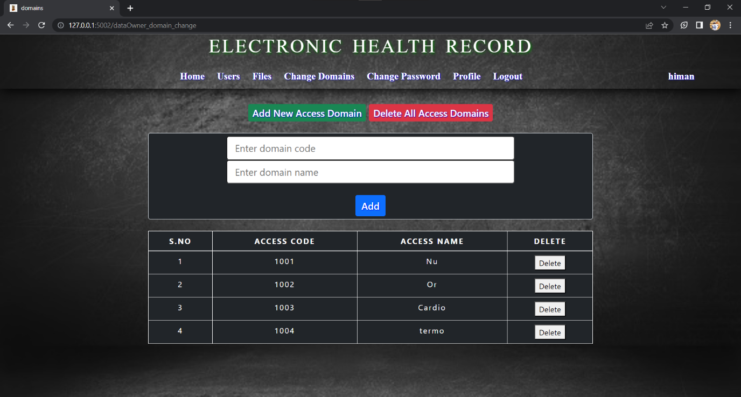

Fig:

This is the domains page, here we can see the domains, add the domains and delete the existed domains.

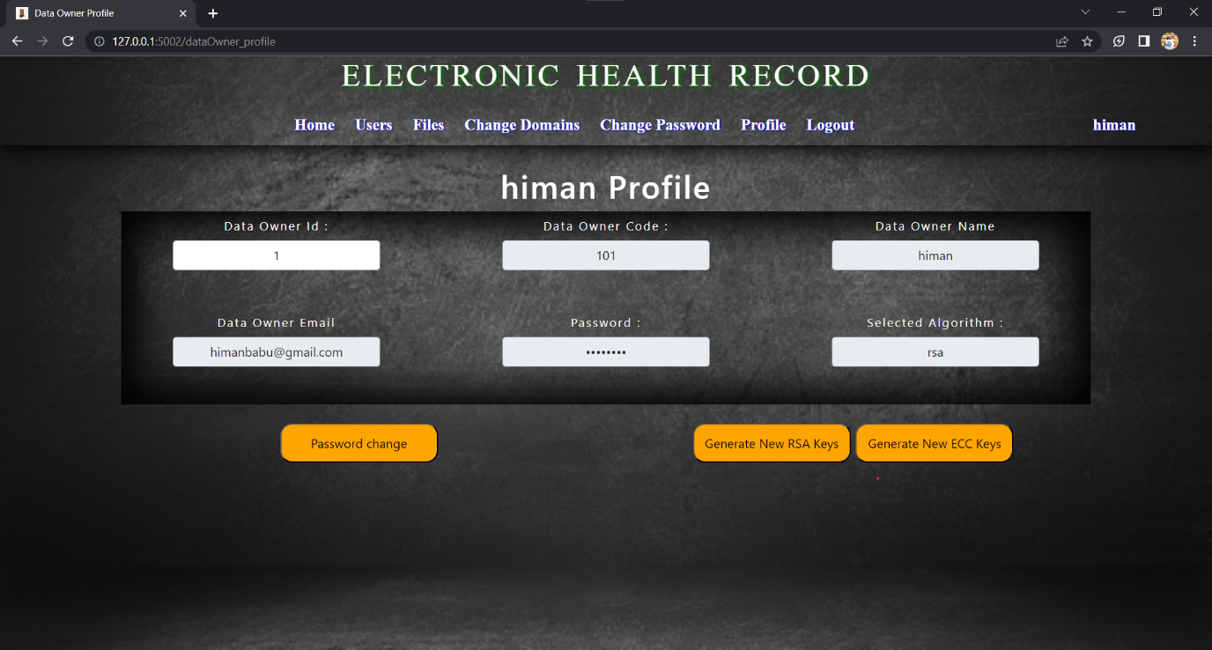

Fig:

This is the data owner profile page, here data owner can see his details and he can change his password by clicking on password change button and can generate new rsa or ess keys for file encryption and decryption.

**Data User:**

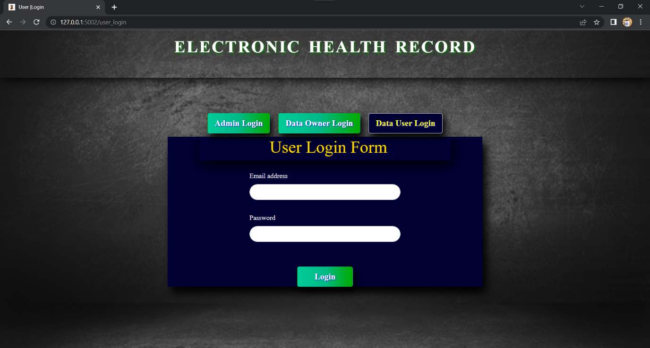

**Fig:**

This is the data user login page, here user can login using his credentials and after successful login he will be redirected to user home page.

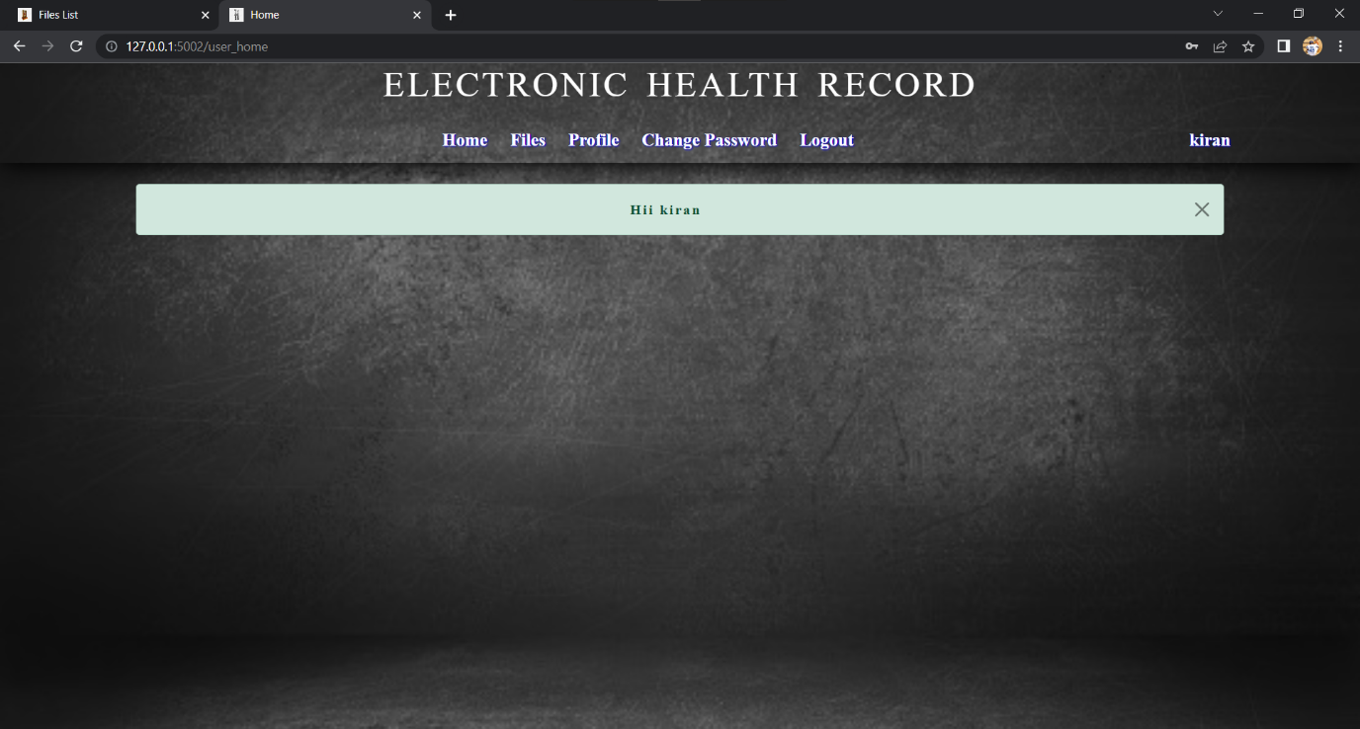

Fig:

In the user home page, we have some options like files, profile and change password. After clicking on the files button we are checking the files which are available for him based on his domain or attriburte.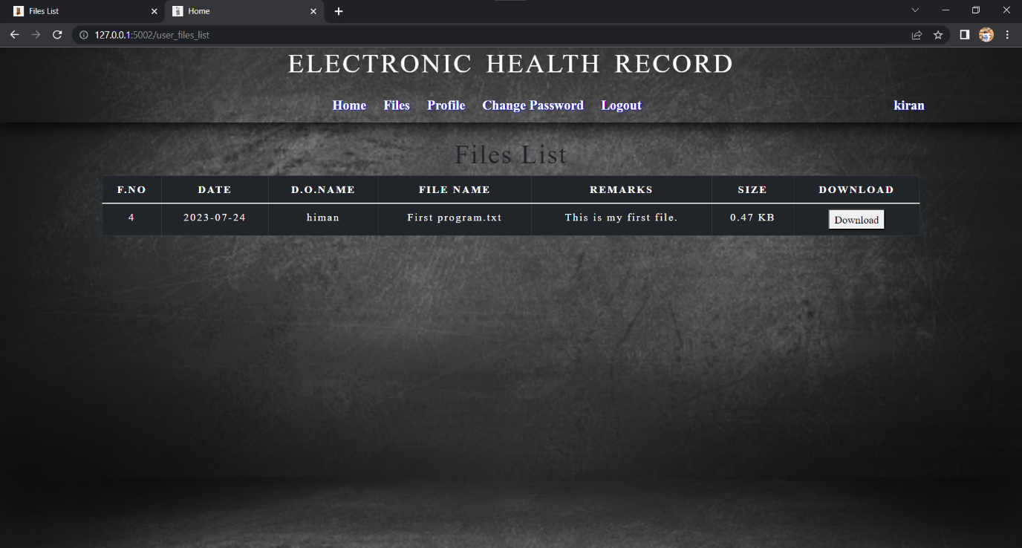

This is the files page, here he can see the list of files which are available to download. After clickingon download button we are retriving file from drivehq and decrypting that file using decryption key. and then he will be redirected to download page there he can download that file to his local system.

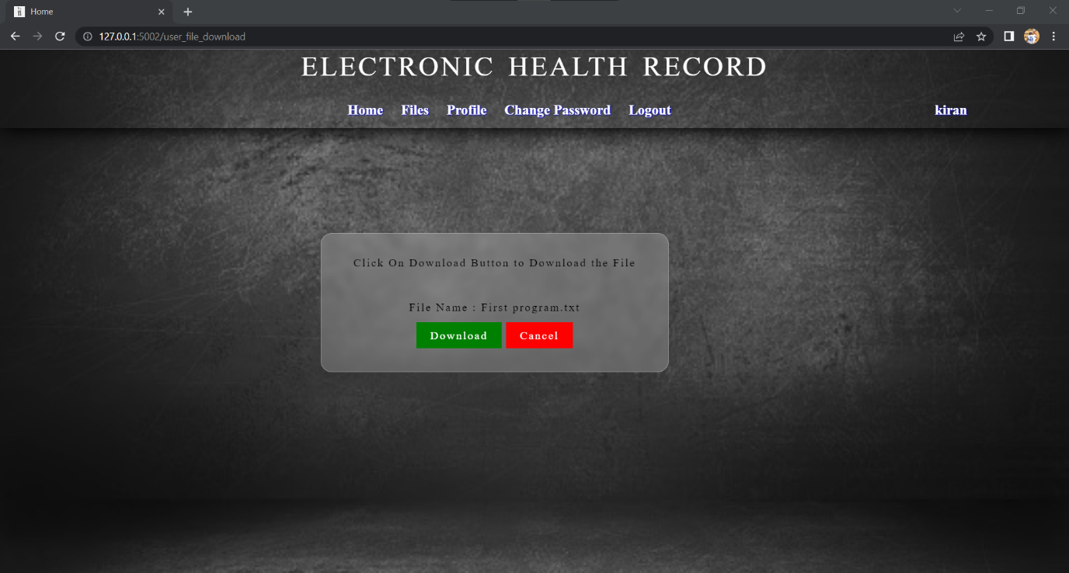

**Fig:**

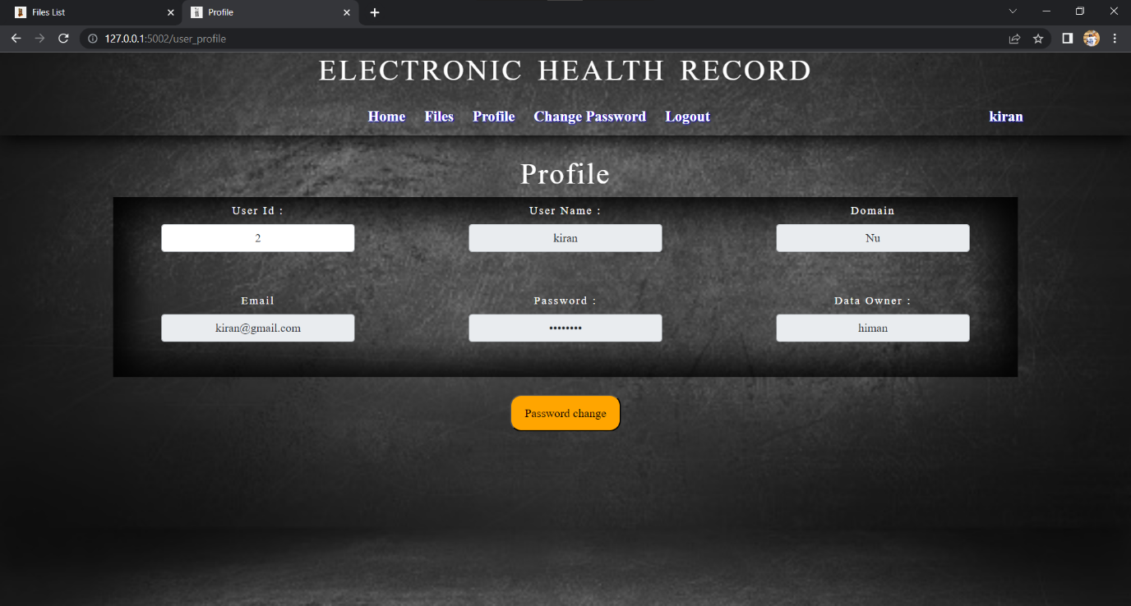

**Fig:**

This is the user profile page here he can see his details and he can change his password using old password and new password he wants keep.

**Software Requirements:**

1. Python 3.10.0
2. Mysql 8.0

**Libraries:**

1. Flask 2.3.2
2. Flask-Mail 0.9.1
3. Flask-MySQLdb 1.0.1
4. pycryptodome 3.18.0
5. tinyec 0.4.0
6. rsa 4.9
7. ecdsa 0.18.0